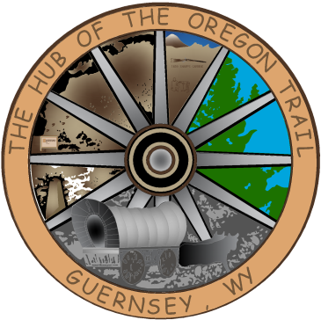

**TOWN OF GUERNSEY**

**October 01, 2024**

* + - 1. Call to Order/Pledge of Allegiance and Welcome
      2. Approval of Agenda
      3. Approval of Minutes September 17, 2024
      4. Consideration of Claims
      5. Public Comments
      6. Proclamation School Lunch Week
      7. Crazy Tony’s Catering Permit
      8. Resolution 2025-005, Appointment of Municipal Officer
      9. Sturdivant
      10. Community/Organization Reports
      11. Department reports
      12. Mayor and Council Member Reports
      13. Announcements
      14. Adjournment

**ANNOUNCEMENTS**

Oct. 15, 2024 Next Council Meeting